Name : Saurabh Sanjay Jadhav

Topic : Docker image and container.

Assignment no. : 5

1. Install Docker on instance.

Yum install docker

1. Start and enable the docker service.

1. Pull the tomcat image from docker.

Docker pull tomee

1. List the docker images.

Docker image ls

Docker images

1. Run the image as docker container.

Docker run tomee

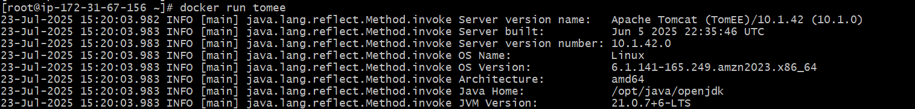

List the docker containers



Remove the container

Docker rm <container-name or container-id>

Use run command again with options. Access the container using ip-address:7070

Docker Run –-name <container-name> -d -p 7070:8080 <image-id>



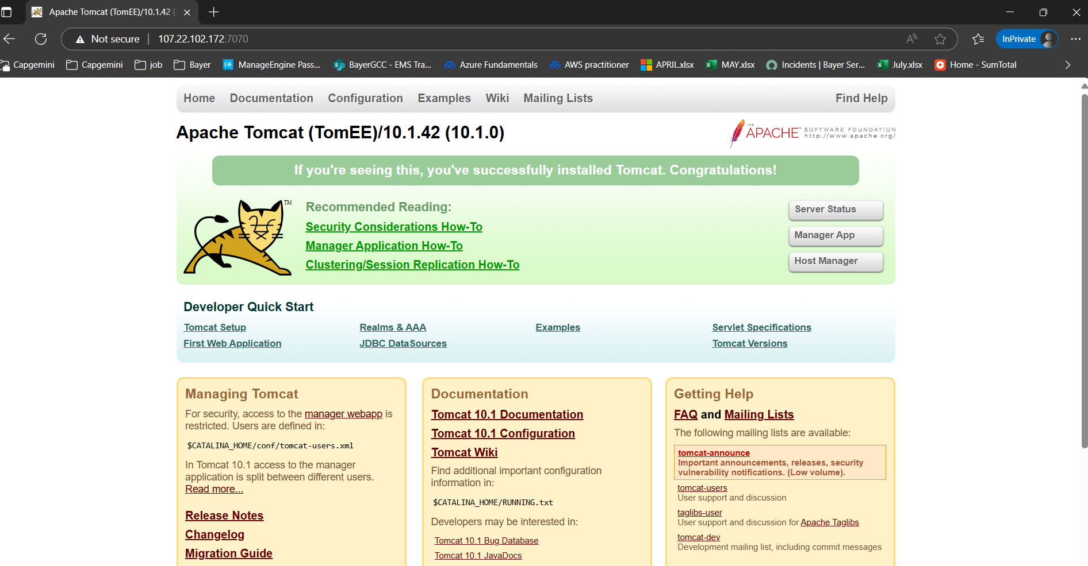

1. Remove container and images.
2. Remove container

Docker stop <container-id>

Docker rm <container-id>

1. Remove image

Docker rmi <image-id>

